HRF Secretariat Report

The HRF Secretariat serves to support the work of the HRF Steering Committee and plays a coordinating role between the various entities making up the HRF governance structure. In this function, the Secretariat is responsible for delivering services in four areas:

1. Proposal Management;
2. Support to the Steering Committee;
3. Communications; and
4. Reporting.

In order to support these activities, the Secretariat also incurs expenses related to office management and travel. This report briefly summarizes the Secretariat’s work in these areas since the last HRF Steering Committee Meeting, held on September 13, 2013.

***1. Proposal management:*** This activity includes advising the Partner Entities and other entities interested in receiving financing from the HRF on proposal development and processing steps, receiving and processing project and program proposals, and advising the Steering Committee on the consistency between original concepts and final proposals in terms of objectives and financing needs.

Since the last Steering Committee meeting, the Secretariat has worked with the Ministry of Planning and External Cooperation (MPCE), the Ministry of Economy and Finance (MEF), relevant Partner Entities, line ministries, and Steering Committee members to try to advance several Project Concept Notes (PCNs) and project documents through the approval process. In particular, the Secretariat supported the MPCE and MEF to present several projects to the Council of Ministers, through the Prime Minister’s Office and the President’s Office.

These include:

1. **Budget support operations:**

* A World Bank led operation of US$10 million that was disbursed on September 30, 2013
* IDB-supervised operations totaling US$21 million including US$14 million for support to Water and Sanitation sector reforms; and US$7 million for support to Transport sector reforms, approved by the Steering Committee on May 13, 2014 through virtual and accelerated procedures
* A World Bank budget support operation of US$17.6 million focusing on Education and Water and Sanitation, to be submitted for SC approval at the May 28 meeting. This operation was initially prepared and approved at concept stage with US$13.0 million in August 2013 before an additional US$4.6 million was added in April 2014.

1. **Other Operations:**

* A World Bank-supervised operation totaling US$15 million for the Education For All Additional Financing (i.e. School Feeding Program) which was approved on April 29, 2014

The IDB is continuing to prepare the project for the rehabilitation of the Peligre-Port-au-Prince transmission line. An amount of US$16 million has been set aside for this operation, including the US$5 million contribution which was recently received from the United States in April 2014.

To assess the efficiency of the HRF grant approval process, the Secretariat continues to analyze the performance of the HRF’s overall grant approval process. On average, the full process took 113 days from the receipt of a project concept note to the transfer of funds to a Partner Entity[1] due to the lengthy time necessitated in processing the Milk Processing and Production project (258 days). Summary information on the time required for each step of the process is provided in Attachment 1.

***2. Steering Committee support:*** This activity involves: organizing Steering Committee meetings (preparation of agenda and background materials in English and French, notification of members, venue logistics); drafting, circulating and disclosing minutes; responding to members concerning questions about Steering Committee matters; notifying the Trustee of funding requests approved by the Steering Committee and communicating instructions for the transfer of funds to Partner Entities; and performing any other functions assigned to the Secretariat by a decision of the Steering Committee.

The Secretariat followed up on the Eleventh Steering Committee meeting, which was held in Port-au-Prince on September 13th, by preparing, circulating and finalizing the minutes of the meeting, informing the relevant Partner Entity about the funding decision and drafting a paper on the future of the HRF. The paper was circulated to SC members on December 18, 2013. All necessary preparations for the Twelfth Steering Committee meeting, to be held on May 28, 2014, have been undertaken. The Steering Committee meeting will be held at the Ministry of Plan and External Cooperation (MPCE) office in Port-au-Prince. Holding Steering Committee meetings at Partner Entity or Government offices saves administrative costs for the HRF. Other activities carried out in support of the Steering Committee include: briefing of the new HRF Chairperson and the new State Secretary for the Economy following the government reshuffle in early April 2014; disclosure of the Trustee and Secretariat reports and minutes from the Eleventh Steering Committee meeting on the HRF website; communication of the decisions made at the Eleventh Steering Committee meeting to the Trustee and Partner Entities; liaising with the MEF and MPCE on forthcoming project proposals for HRF financing; and responding to a variety of member requests for information.

***3. Communications:***

Since the last Steering Committee meeting, the Secretariat has:

* Issued the press release for decisions of the 11th Steering Committee meeting
* Aired HRF radio spots on Caraibe and Metropole stations
* Aired HRF TV spots on Caraibes and Television Nationale de Haiti
* Updated the website on a regular basis
* Distributed the 2012-2013 Annual report
* Prepared and distributed the 2014 HRF calendar
* Completed and distributed the Fall 2013 Quarterly Update
* Completed and distributed the Winter 2013 Quarterly Update
* Completed the Spring 2014 Quarterly Update
* Started the process of redesigning the HRF website
* Met with media members to raise awareness about the HRF and its activities
* Conducted site visits to HRF-financed projects in Port au Prince, Jacmel, Thomazeau, and Cap Haitien to stay updated on the progress of projects
* Published, jointly with the executing agencies, two newspaper articles related to the site visits and projects results
* Created a portfolio of over 1,000 pictures of the projects from the field visits
* Created a portfolio of over 300 pictures from pictures available through our partner entities
* Met with partners to keep them informed of the activities
* Prepared the 4th annual HRF photo exhibit

The Secretariat met also with current and potential future donors, project proponents, and other interested parties, at their request to explain the operations of the HRF and provide any additional information required.

***4. Reporting:***  The Secretariat is responsible for: receiving and consolidating annual reports on implementation results; receiving periodic/quarterly reports submitted by the Partner Entities for distribution to the Steering Committee and all HRF donors; collaborating with the Trustee to ensure that the Trustee has all the information necessary to carry out its responsibilities; and responding to public inquiries concerning implementation results and financial performance.

The Secretariat prepared and distributed the Winter 2013 and Spring 2014 Quarterly Update. The latter was issued on May 20, 2014 and will be made available to SC members at the May 28, 2014 meeting. Following the finalization of the 2012-2013 Annual Report , both English and French texts were shared in draft with the Steering Committee on August 5, 2013 and widely distributed to HRF stakeholders and partners, including government officials, donors, national and international NGOs, etc. on November 27, 2013.

1. ***Office and travel:*** In order to fulfill its responsibilities, the Secretariat must undertake: equipping and maintaining an office; maintaining a vehicle and driver; financing the communications strategy; printing reports and other documents for Steering Committee meetings; and translating communications materials, reports and Steering Committee documents. Since the last Steering Committee meeting, the Sr. Operations Officer presented the HRF experience and lessons learned at the March 2014 Haiti Renewal Alliance’ conference in Port au Prince and the Fund Manager made a similar presentation to the International Institute for Infrastructure Resilience and Reconstruction Conference (Purdue University, May 21, 2014). To maintain mobility, the Secretariat procured a new vehicle to replace its original transportation. The new vehicle was operational in November 2013 and the existing HRF vehicle was donated to the MPCE in April 2014.
2. ***Secretariat FY14 activities***. Following Steering Committee approval of the Secretariat and Trustee budgets for FY14 in May 2013, the HRF Secretariat prepared its third year work program covering the period from July 2013– June 2014. With a portfolio of nineteen (TBC) projects, the Secretariat continued its focus on reporting, with Quarterly Updates (Fall, Winter and Spring) and a larger annual report (prepared during the summer).

The Secretariat will continue to provide a Secretariat Report at each Steering Committee meeting and will work with the Partner Entities to increase the project-level results reporting. The HRF Secretariat is actively engaged in increasing HRF visibility and communications activities by implementing the communications strategy, as mentioned above. In terms of proposal management, the HRF Secretariat will continue to work with the MPCE, the SC Chairperson and Brazil in order to develop the project pipeline and monitor the performance of the grant approval process.The Secretariat will continue to provide support to the Steering Committee on a day-to-day basis. Finally, t

Following the Eleventh Steering Committee meeting discussion on the future of the HRF, the Secretariat maintained close contact with the HRF Chairperson (formerly Minister Wilson Laleau and currently Minister Marie Carmelle Jean-Marie) to follow-up on the Government position on the discussion paper that was reviewed at the previous SC meeting. So far, a formal Government position has yet to be confirmed and the Secretariat is following up to see whether discussion at the Council of Ministers is still warranted.

1. ***Secretariat budget.***
2. The Steering Committee approved the allocation of US$892,000 for the FY14 budget for the Secretariat and Trustee. In the Secretariat and Trustee’s continuing effort to control HRF administrative expenses, projected expenditures to the end of June 2014 should remain within the authorized limits.
3. At end of April 2014, the Secretariat expenditure rate was 71 percent (to be compared with an average of 79 percent for this time of the year) and the actual total incurred expenses are estimated at US$636,000 which is US$60,000 below the actual expenditure rate at the end of April 2013. This reduction in expense was achieved despite inclusion of payment for the new vehicle in FY14 that should have been posted to the FY13 budget. The savings in current spending resulted also from costs savings across the board, a reduction in the frequency of Steering Committee meetings during this fiscal year, a smaller number of proposals developed and submitted for Steering Committee approval, lower-than-expected costs for reporting activities, and mostly from the ability of Secretariat staff to charge portion of their time to other Bank activities and units for cross-support.
4. The Trustee’s FY14 costs are expected to be lower than the estimates approved by the Steering Committee, at $103,000 and resulting in an estimated savings of approximately US$ 13,000 (11.2% of the approved FY14 amount). These savings were due to i) lower-than-expected volume of transactions and processing cash transfers, ii) fewer HRF Steering Committee meetings than anticipated, iii) lower investment management fees reflecting a lower average balance in the trust fund, iv) lower accounting costs reflecting less volume of transactions, and vi) lower legal costs.
5. The FY15 budget proposal for the Secretariat and Trustee is presented with two options depending on the SC’s decision about the future of the HRF. Whichever option is selected, there will be a sharp drop of approximately 45-54% from FY14 and a more than 70% reduction from the original FY11 budget. This steep reduction is predicated upon: (i) the downsizing of the Secretariat’s responsibilities regarding the Steering Committee, Proposal Management and Communication; (ii) the departure of the current Program Manager who will be replaced by the Sr Operations Officer at the end of May 2014; and (iii) related reductions in expenses.
6. ***Personnel changes***. In December 2013, the Secretariat hired a new Senior Operations Officer, Mr. Mamadou L. Deme, to replace the outgoing one, (Ms. Maria Kim). As mentioned above, the Program Manager is leaving the Secretariat and will be replaced by the Sr Operations Officer who is already on the Secretariat’ staff.

**ATTACHMENT 1**

Performance of HRF Grant Approval Process

***1. HRF grant approval process* –** The revised grant approval process wasapproved by the Steering Committee in July 2012, and consists of six simple steps as detailed in Figure 1. Performance standards are established by the MPCE with the support of the Secretariat. The HRF grant approval process is aligned with the MPCE project review process to facilitate a fluid processing of funding requests.

***2. Average processing time -*** As of May 2014, the average processing time from the submission of a project concept note to the HRF by the GoH up until the transfer of funds by the Trustee to the Partner Entity was 113 days[2] with the total processing time per project varying from 11 days for the IHRC Capacity Building Program to 258 days for the Milk Production and Processing project (Figure 2). On average almost half of the processing time (58 days) was used to prepare the full project document. The performance standard for the approval of the project concept note and the approval of the full project document by the HRF Steering Committee were closely adhered to with these steps taking respectively on average 9.1, and 8.2 days. The HRF recently showed its capacity to rapidly respond to Government financing requests by processing the request for funding of the budget support operations supervised by the IDB (US$21 million) and of the Education For All project additional financing managed by the World Bank (US$15 million) which were all approved within 5 working days (including the concept notes for the IDB supported activities) .



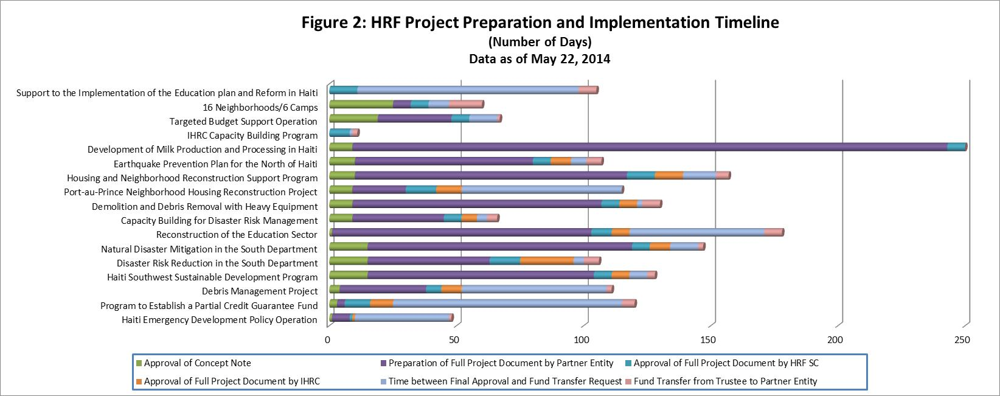

1. The average includes only those projects (14) which have completed all steps, i.e. funds have been transferred to the Partner Entity.
2. The average includes only those projects (18) which have completed all steps, i.e. funds have been transferred to the PE.